Name: Feda Bigzad
Course: Data Structures
Date: December 17, 2025
Final Project Summary and User Guide
MM Packaging Inventory Management System (MM-IMS)
1. The Problem Being Solved
MM Packaging uses multiple departments (Offset Press, Label, and Bindery), and each department consumes different materials (paper, ink, label stock, cartons, shrink wrap, etc.). A common real-world problem is that inventory information becomes outdated when materials are used, transferred, or received without a consistent tracking method. This can cause low-stock surprises, delays, and confusion between departments.
MM-IMS solves this problem by providing a simple, menu-driven system that tracks inventory quantities for each department, records transactions, and produces reports such as low-stock alerts and item transaction history. The system is designed to be realistic but small enough to demonstrate core Data Structures and file handling skills.
2. Approach Taken
The solution is a console-based C++ program that organizes inventory by department and stores materials inside a custom linked list. The user interacts through a text-menu interface to complete tasks such as:
- Add a material item
- Receive materials (increase quantity)
- Use materials (decrease quantity)
- Transfer materials between departments
- Sort items by name or quantity (merge sort)
- Generate a low-stock report
- Undo the last transaction (stack-based undo)
- Save/Load inventory and transactions using text files
The program maintains a transaction log and uses input validation and exception handling to prevent invalid inventory operations (such as using more inventory than available).
3. Concepts Used by the Program
This project intentionally applies course topics:
3.1 Data Representation and Classes
The system models real inventory objects using classes/structs such as:
- MaterialItem (id, department, name, unit, quantity, reorder level, active/inactive)
- Transaction (timestamp, type, item id, from/to department, quantity)
- DepartmentInventory (holds a linked list of items for that department)
- InventorySystem (main controller for menus, I/O, and operations)
3.2 Data Structures
- Custom Linked List: stores materials for each department
- Custom Stack: stores recent transactions for undo functionality
- Queue (optional): used to queue reorder requests when an item becomes low-stock
- Vector (STL, helper only): used for transaction history storage
3.3 Algorithms
- Merge Sort on Linked List: sorts materials by name or quantity
- Linear Search: finds items by ID or name
- Greedy filtering: low-stock report selects all items where quantityOnHand < reorderLevel
3.4 File I/O and Persistence
- Loads inventory from materials.txt at startup
- Appends transactions to transactions.txt as operations happen
- Saves updated inventory back to materials.txt when the user selects Save or Exit
3.5 Exception Handling and Input Validation
- Handles file failures (missing file, cannot open)
- Blocks invalid inputs (non-numbers, negative values, out-of-range values)
- Prevents logic errors (cannot use/transfer more than available)

4. Inputs and Results
Inputs
The program uses two input sources:
- User input via console menus
  - menu selections
  - material details
  - quantities
  - item IDs
  - department choices
- Disk files
  - materials.txt (inventory master list)
  - transactions.txt (transaction log)
Results / Outputs
- Updated on-screen inventory views and reports
- Low-stock report displayed in console
- Saved inventory file (materials.txt)
- Appended transaction log (transactions.txt)
- Optional queue display for reorder requests
- 5. Sample Input and Output Files
- 5.1 Sample materials.txt (Input / Output)
- File name: materials.txt
Format: id|department|name|unit|quantityOnHand|reorderLevel|isActive

# id|department|name|unit|quantityOnHand|reorderLevel|isActive
1000|Offset Press|70# Gloss Text Paper - 28x40|sheets|5000|1500|1
1001|Offset Press|Black Ink|lbs|120|40|1
1002|Label|Label Stock - 4in Roll|rolls|80|25|1
1003|Bindery|Shrink Wrap|rolls|18|10|1
5.2 Sample transactions.txt (Output Log)
File name: transactions.txt
Format: timestamp|actionType|itemId|fromDepartment|toDepartment|quantity
2025-12-01 10:15:00|RECEIVE|1002||Label|10
2025-12-01 11:00:00|USE|1000|Offset Press||500
2025-12-01 11:30:00|TRANSFER|1000|Offset Press|Bindery|200
2025-12-01 11:35:00|UNDO_TRANSFER|1000|Bindery|Offset Press|200

6. Sample Program Input and Output (Console Example)
Sample actions performed
- Receive 10 rolls of Label Stock (ID 1002)
- Use 500 sheets of paper (ID 1000)
- View low-stock report
Example console output
MM Packaging Inventory Management System
Main Menu
1) Manage Offset Press
2) Manage Label
3) Manage Bindery
4) Low-stock report
5) Undo last transaction
6) Search material
7) Transaction history
8) Save
0) Save and Exit

Choice: 2

Department Menu — Label
4) Receive material
Choice: 4
Enter item ID to receive: 1002
Quantity to receive (>0): 10
Received. New qty: 90

Main Menu
Choice: 1

Department Menu — Offset Press
5) Use material
Choice: 5
Enter item ID to use: 1000
Quantity to use (>0): 500
Used. New qty: 4500

Main Menu
Choice: 4

=== LOW STOCK REPORT (Qty < Reorder) ===
Department: Bindery
ID Unit Qty Reorder Name
1003 rolls 18 10 Shrink Wrap

7. Screenshots Demonstrating the Program Runs

- Startup screen showing the main menu and that data loaded successfully.
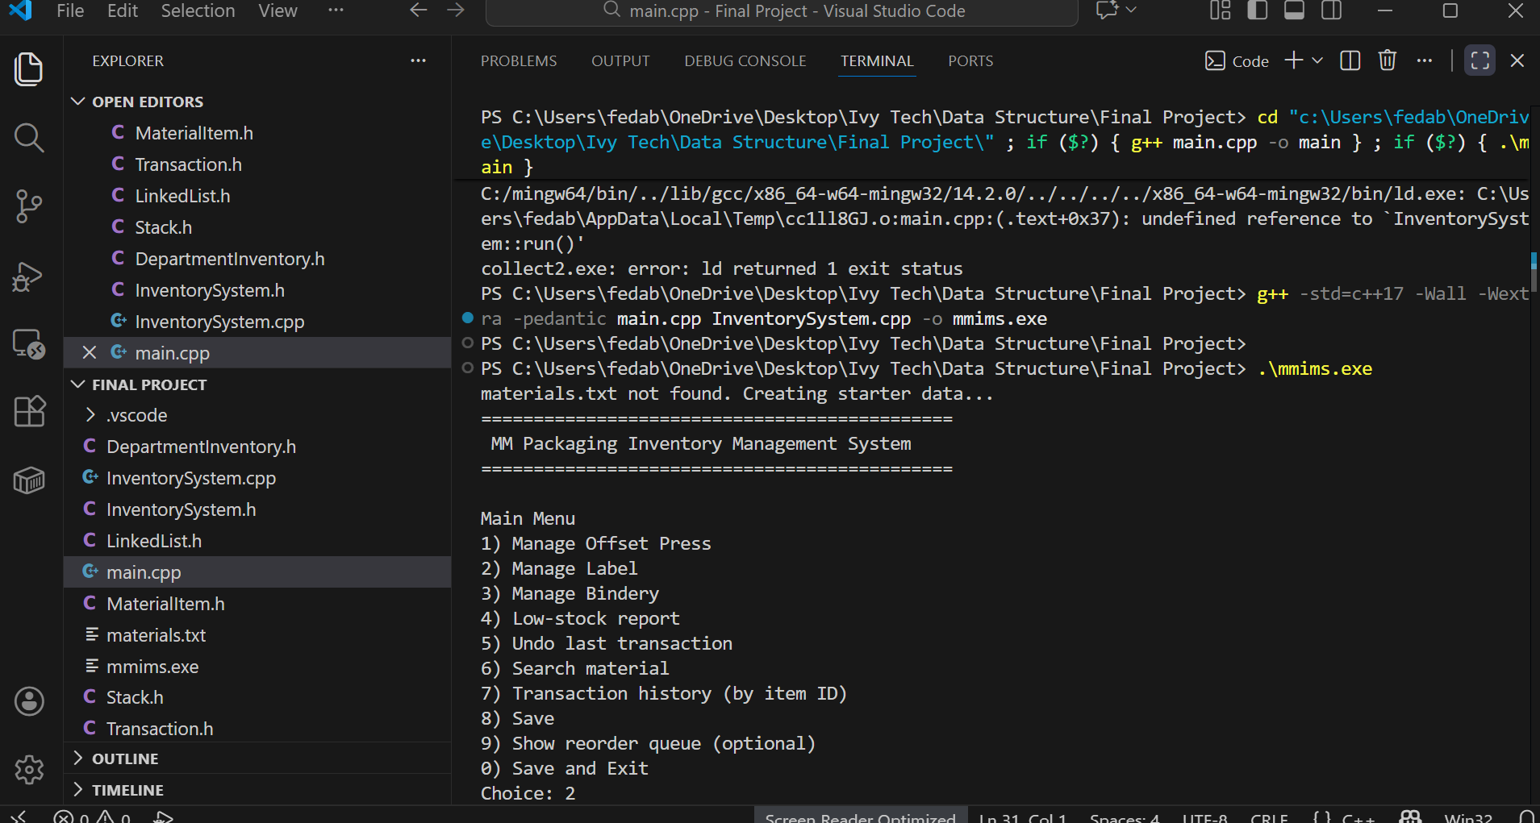
- Department inventory list (example: Label).
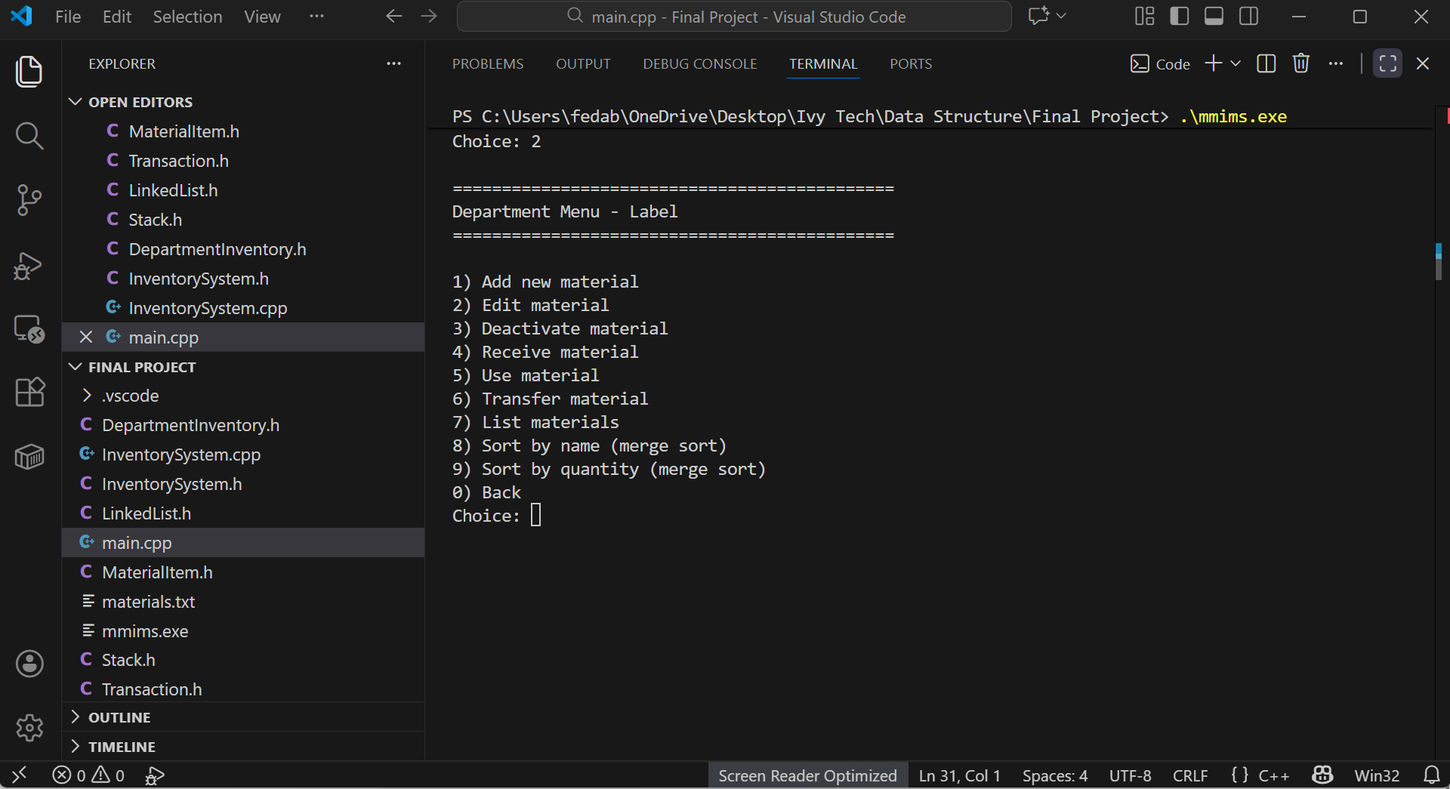
- Add New Material
- Input the Name
- Unit of measurement
- Starting Quantity
- Reordering Quantity.
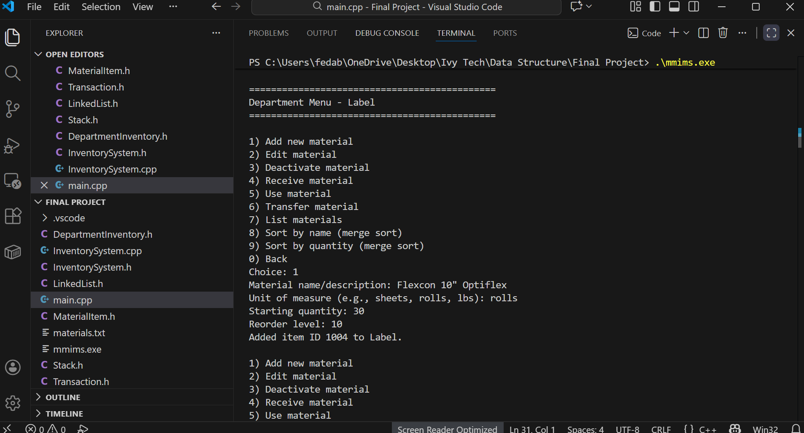

8. Lessons Learned
This project improved my understanding of practical software design using data structures:
- Linked lists are useful for dynamic storage and recursive sorting but require careful pointer management.
- Merge sort works well for linked lists because it does not require random access.
- Stacks are a natural fit for implementing undo operations because they reverse the last action first.
- File I/O makes the program realistic by saving state, but requires strong validation and error handling.
- Input validation and exceptions are essential to prevent inventory corruption and to make the program reliable.
9. Changes from the Initial Proposal
Compared to the initial proposal, the final implementation included the same core goals, but a few adjustments were made for simplicity and reliability:
- The program uses pipe-delimited text files (easy to parse and human-readable).
- The “Purchasing reorder queue” feature is included as an optional queue display rather than a full purchasing module.
- Transactions are appended immediately to the transaction file for safety and auditing.
- The system focuses on one user role (“Inventory User”) to keep the interface clear and consistent.
Overall, the final project stayed aligned with the proposal while refining the design to ensure it compiles cleanly, runs reliably, and demonstrates the required course concepts.
10. User Guide (How to Use the Program)
10.1 Program Setup
- Put the program files in one folder (source code + executable).
- Run the program.
- If materials.txt does not exist, the program automatically creates starter inventory data.
10.2 Navigating Menus
- The program is menu-driven.
- Enter the number of the option you want, then press Enter.
- Enter 0 to go back or exit (depending on the menu).
10.3 Common Tasks
A) Add a New Material
- From Main Menu, choose the department (Offset Press, Label, Bindery).
- Choose Add new material.
- Enter name/description, unit, starting quantity, and reorder level.
- The system assigns an ID automatically and stores the item.
B) Receive Material (Increase Quantity)
- Enter the department menu.
- Choose Receive material.
- Enter item ID and quantity received.
- Quantity increases and a RECEIVE transaction is logged.
C) Use Material (Decrease Quantity)
- Enter the department menu.
- Choose Use material.
- Enter item ID and quantity used.
- The program validates that enough inventory exists.
- Quantity decreases and a USE transaction is logged.
D) Transfer Material Between Departments
- Enter the source department menu.
- Choose Transfer material.
- Enter item ID, destination department, and quantity.
- The program decreases source quantity and increases destination quantity.
- A TRANSFER transaction is logged.
E) Sort Inventory (Merge Sort)
- Enter a department menu.
- Choose Sort by name or Sort by quantity.
- Choose List materials to view the sorted results.
F) Low-Stock Report
- From Main Menu, choose Low-stock report.
- The program prints items where quantityOnHand < reorderLevel.
G) Undo Last Transaction
- From Main Menu, choose Undo last transaction.
- The program reverses the most recent RECEIVE/USE/TRANSFER.
- An UNDO transaction is recorded.
H) Save and Exit
- Choose Save anytime to write updated inventory to materials.txt.
- Choose Save and Exit to save and close the program safely.

